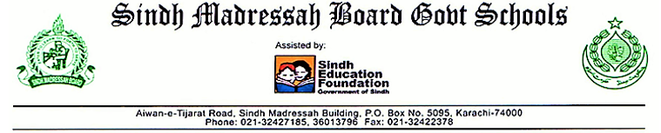

CLASS ROOM OBSERVATION FORM
School: ____________ Grades: __________ Subject: _____________
Teacher: _________ Date: ___/____/____ Observer: ____________

S no | Focus on Observation | PERFORMANCE INDICATORS | Strong | Some | None
1 | Teacher | - Personality.  - voice clarity.  - command of subject matter.  - clarity of explanation.  - STUDENT’S interest.  - monitoring of students.
2 | Teaching methodology | - Organization of subject matter.  - Contextual.  - provoke critical thinking.  - MOTIVATOR FOR students.  - questioning technique.  - activity  - individual  - pair
3 | student | - students’ attention.  - students participation.  - behavior of students.
4 | class room management | - class start on-time  - Airy  - light  - cleanliness.  - seating arrangement.  - classroom resources
Comments:
Teacher’s Sign: _______________
Coordinator’s sign: _____________
Principal’s sign and remarks: ___________________________________________________________

